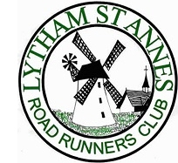

2017/2018 Road Championship Races

- 24/09/2017 Run Preston 5k (11year +) 2k (U11)
- 22/10/2017 Green Drive JNR Mile
- 26/11/2017 Best 5k and 1 Mile Race
- 17/12/2017 Parkview Junior Parkrun
- 28/01/2018 Avenham Park Junior Parkrun
- 04/02/2018 Parkview Junior Parkrun 1st Birthday
- 07/05/2018 Avenham Park 5k & 1Mile Fun Run

(I had to change the Crazy Calf Race as it was moved to end of June which would be too late for the annual Presentation)

Reserve Race:

- 20/05/2018 Junior and Mini Great Manchester Run

Dates are provisional and subject to change.

Should a race be cancelled an alternative will be chosen.

